**Experiment-6**

**Aim:** To perform docker linking and monitoring.

**Docker-Linking:**

**Follow the steps below.**

**Step1:**Create and run a container in detached mode with name ‘db’ from the image “training/postgres”.

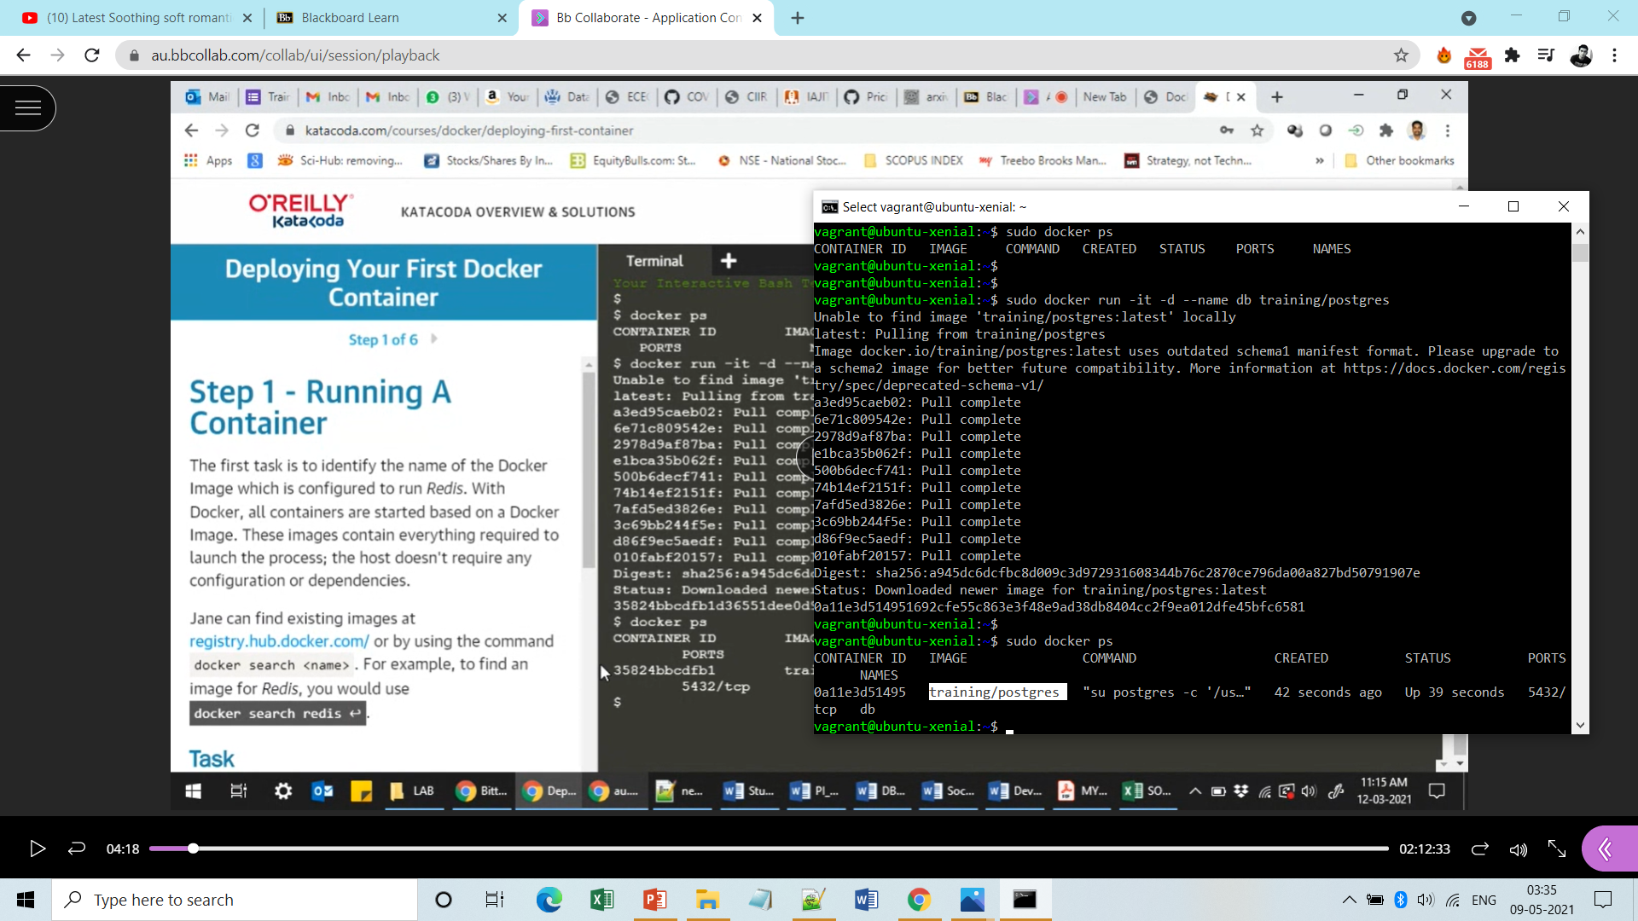

**Step2:** Create and run another container in detached mode with n ame ‘web’ from the image “training/webapp” and link it with ‘db’.

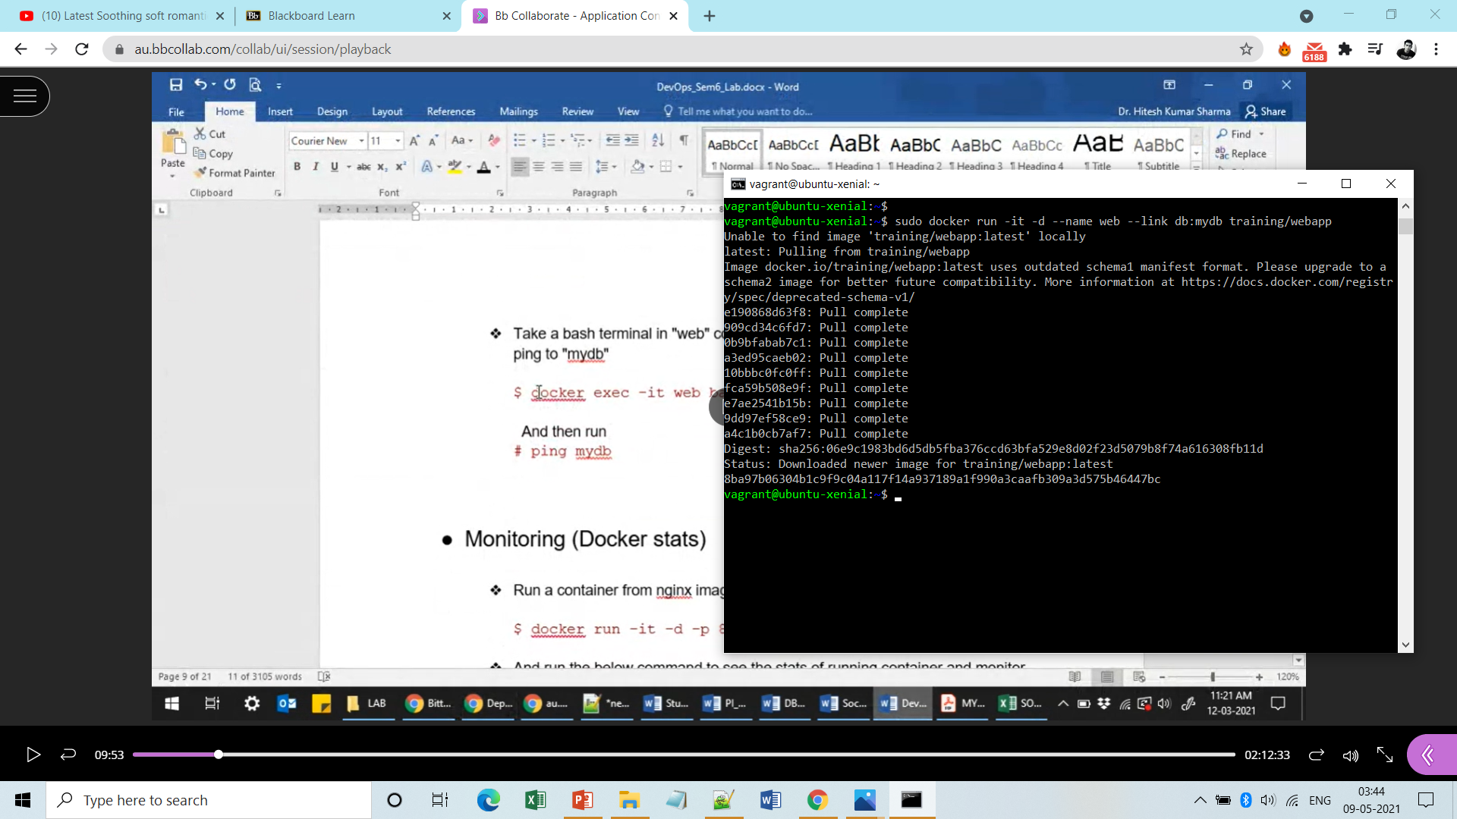

**S** **tep3:** Check whether the above two containers are running or not.

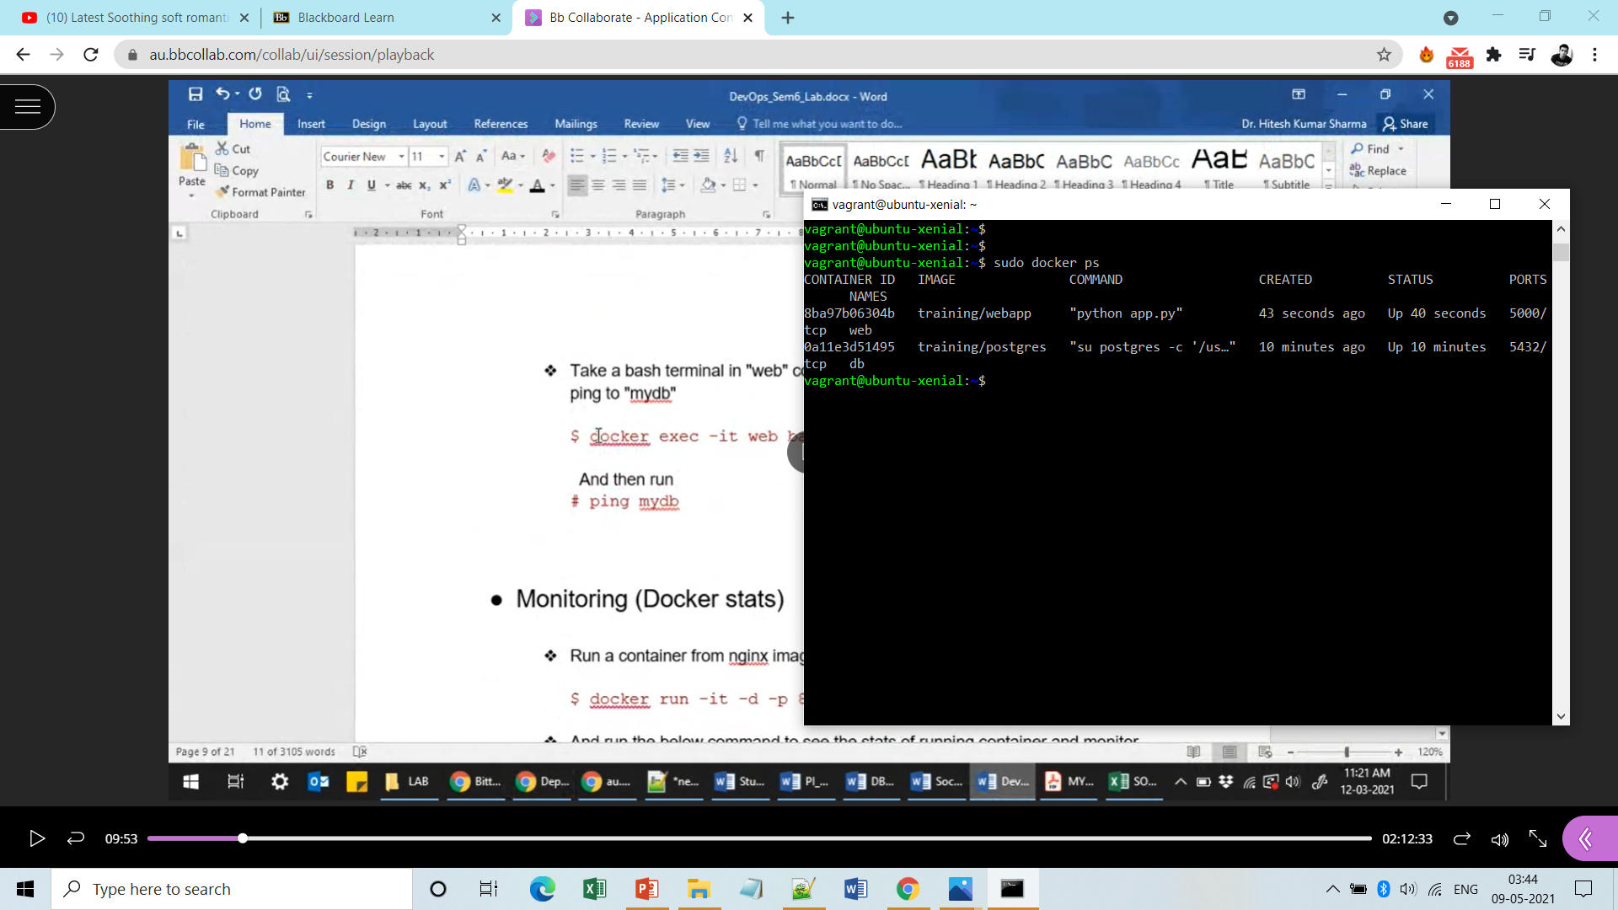

**Step4:** Now enter into the running container ‘web’ and ping to ‘db’.

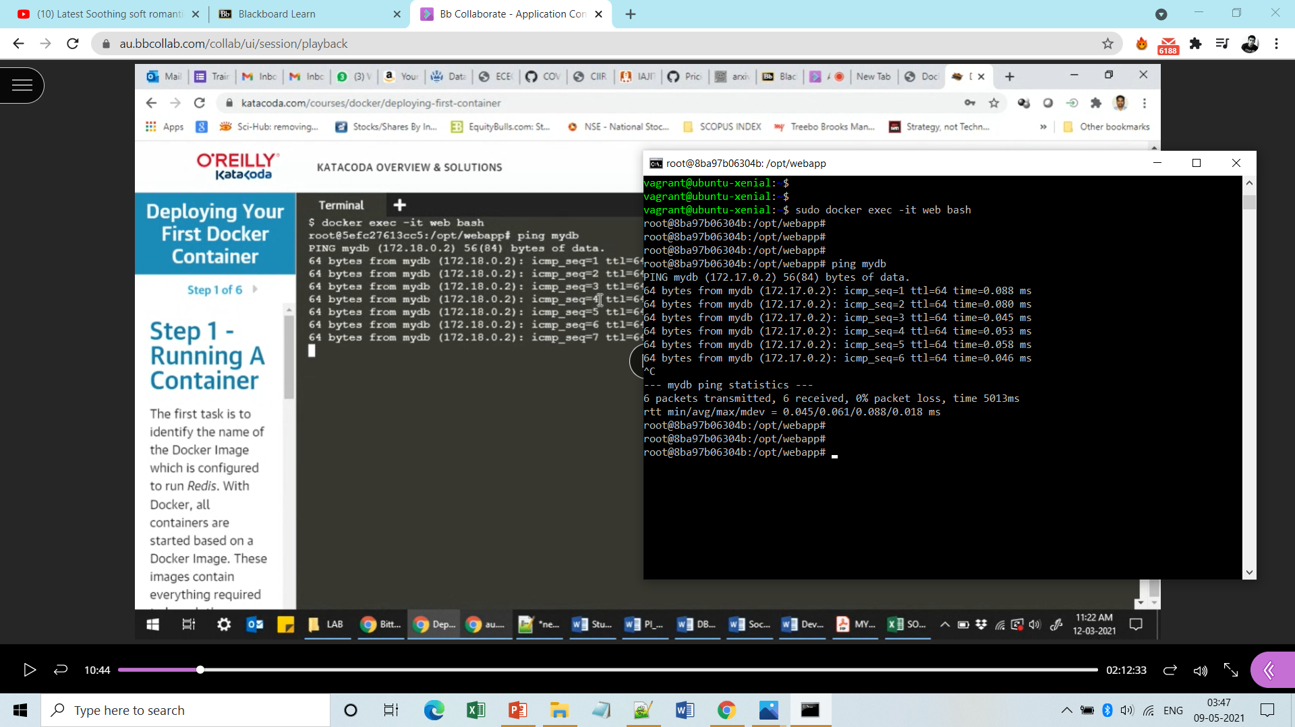

**Docker-Monitering:**

**Follow the steps below.**

**Step1:** Create and run a container from nginx image and map to port 80 with the system port 80.

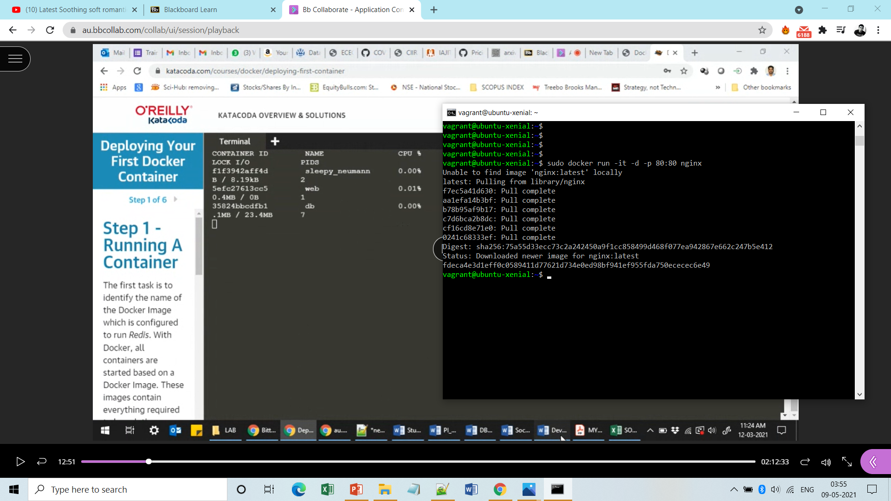

**Step2:** List the containers to get the id’s.

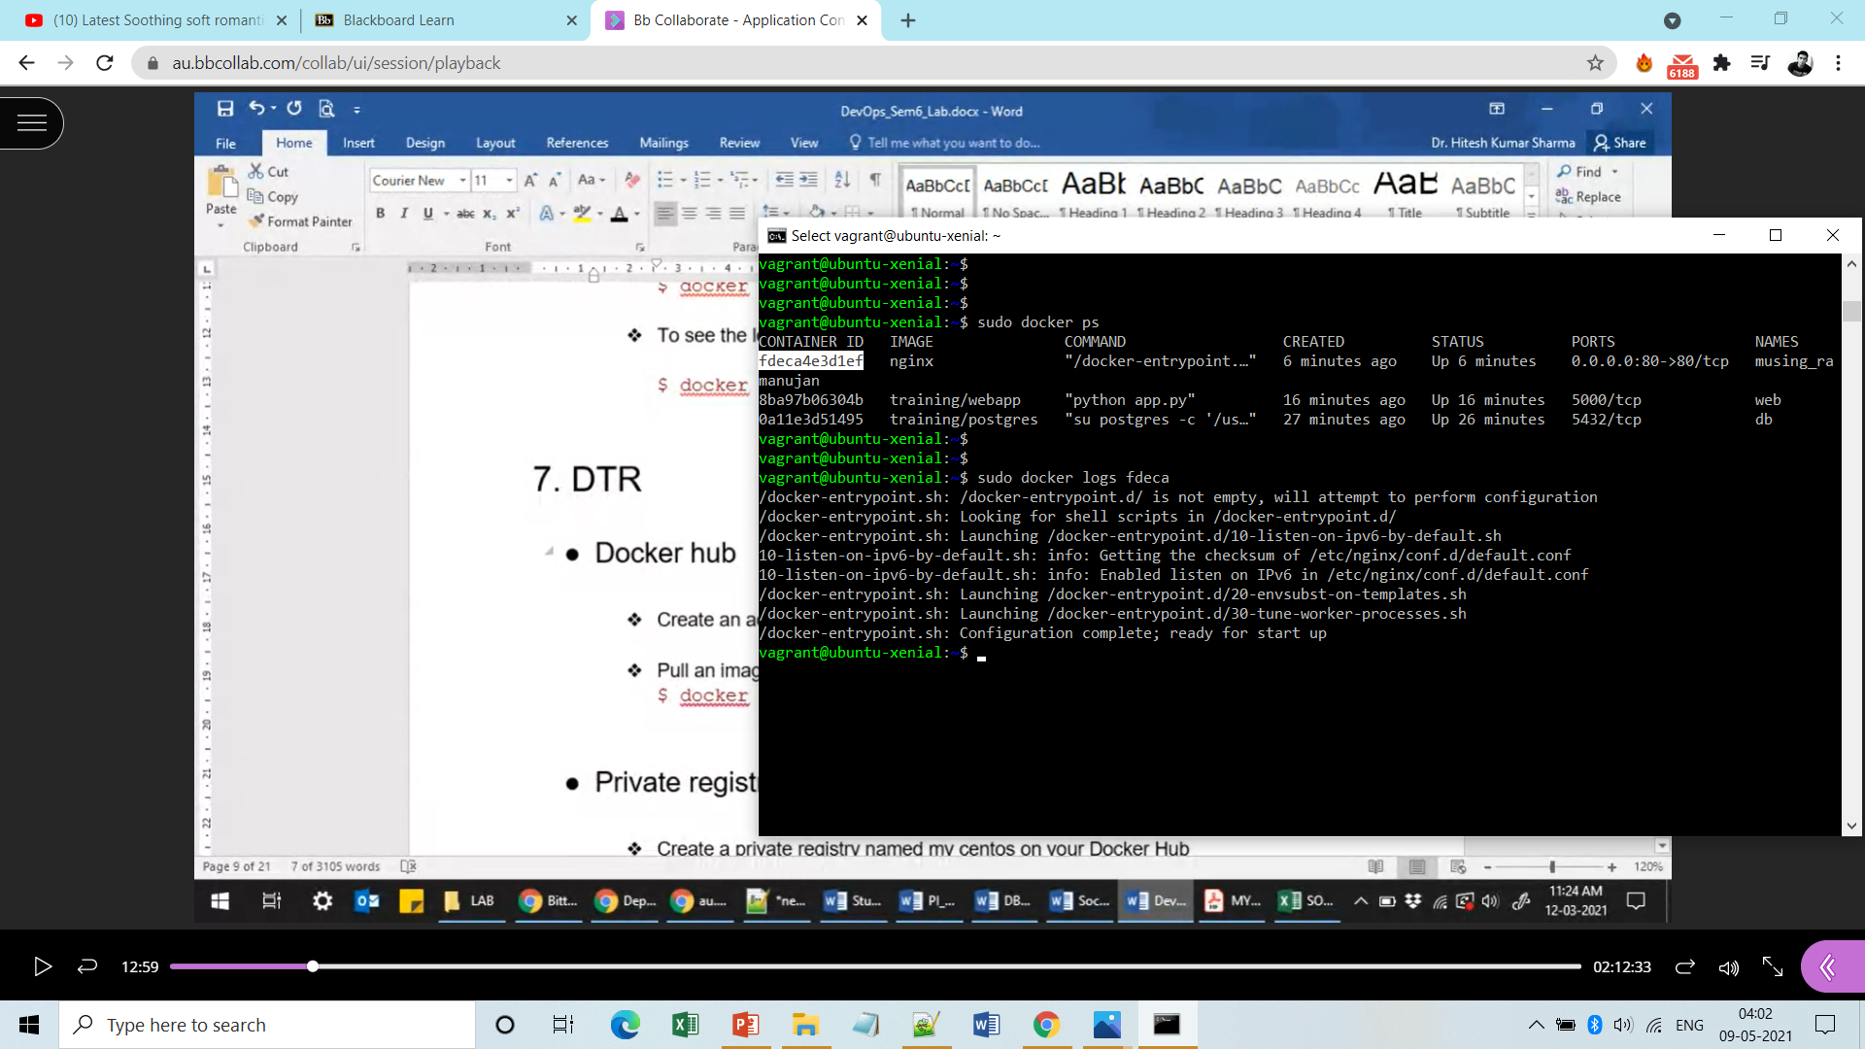

**Step3:** Get the stats of any container by running the command ‘’docker ststs” .

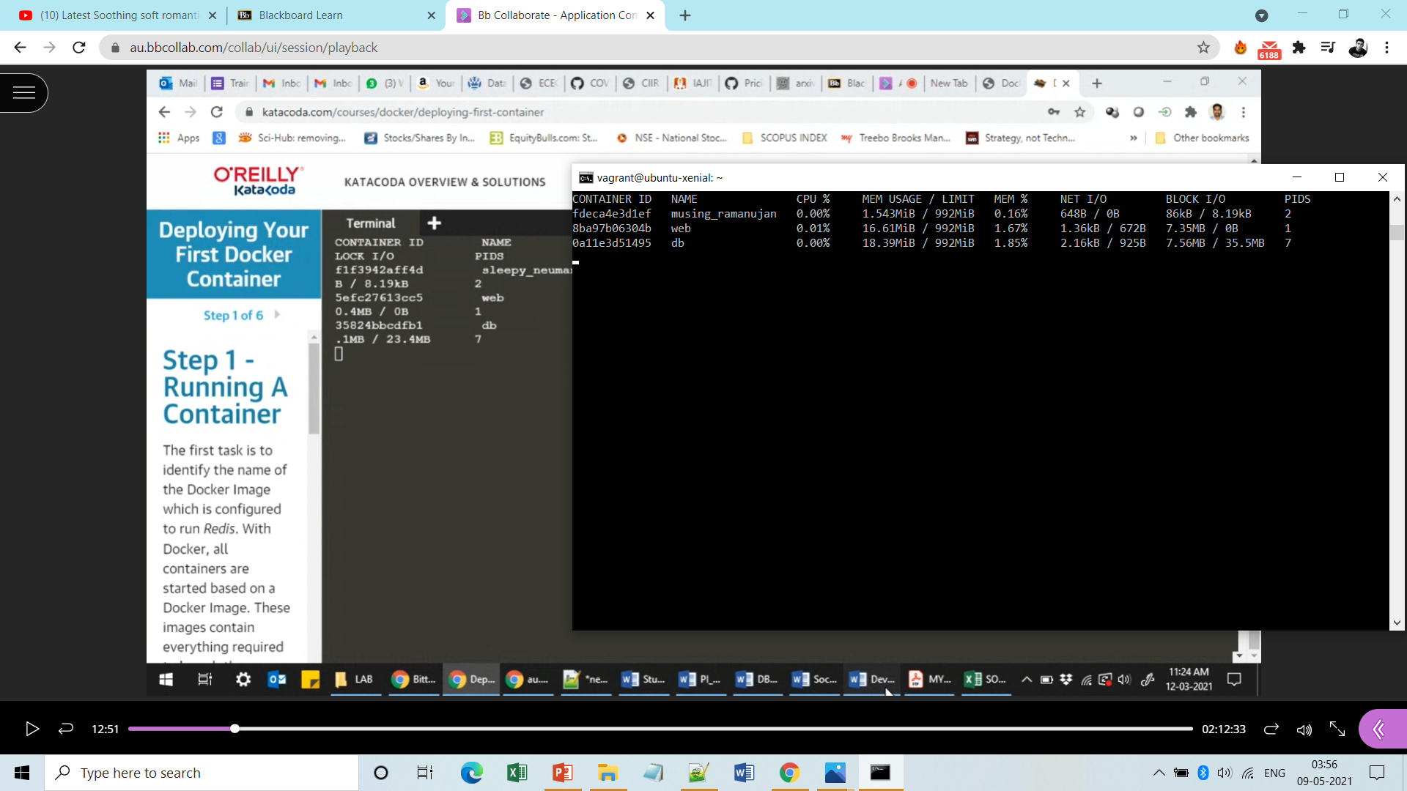

**Step4:** To know the logs of any specific container run the following command.



**Done!**